How much do I know?

Statistics (Handling data)

Try this first:

Alfie asks some boys and girls about their favourite hobby. He shows the results on a graph.
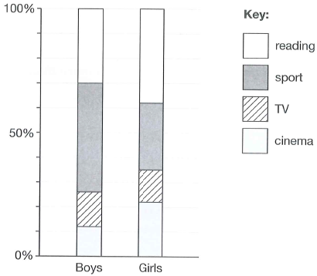

(a) The graph shows that 44% of boys chose sport. Estimate the percentage of girls who chose sport.
(b) 120 boys chose reading. Estimate the number of boys who chose cinema.

Answers:

(a) Between 25% and 30%

(b) Between 44 and 52

What is this topic?

Statistics (or Handling Data) is all about the collection, organization, representation and interpretation of data.

Collection of data is usually by means of a questionnaire or a tally chart, as shown below

Favourite colour | Tally | Frequency

Representation can be in the form of bar charts, pictograms, pie charts, line graphs, Venn diagrams and Carroll diagrams.

Bar charts use columns or bars with a constant width. Frequencies are represented by the heights of the bars. For discrete data (i.e. things that can be counted) there should be gaps between the bars. For continuous data (things that can’t be counted, e.g. measurements) there is no gap between the bars. The chart is then more properly called a histogram.

Pictograms use little pictures or icons to show data. They must always include a key.

Pie charts use sectors of a circle (or slices of a pie) to show data. The size of each sector indicates the frequency. The sum of all the angles at the centre must total 360⁰.

Line graphs use points joined by straight lines to show the relationship between two things (variables), one on each axis.

Venn diagrams use circles to sort things into groups called sets.

Carroll diagrams use a grid (or two-way table) to sort things.

There are three different measures of the average value of a set of data:

- Mean, which is where you add up all the values and divide by how many there are.
- Median, which is the middle value when they are all in order.
- Mode, which is the value that occurs most often.

The range of a set of data is the biggest value minus the smallest.

Questions

Q1.
In a survey people were asked if they like tea and coffee. The results are shown in this Venn diagram.
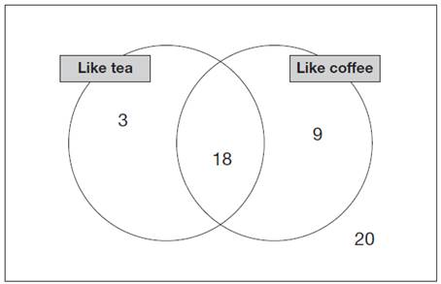

(a) What percentage of people in the survey like both tea and coffee?
(b) What percentage of people in the survey do not like coffee?

Q2.
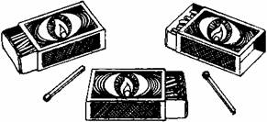

Carol counts the matches in 10 boxes. She works out that the mean number of matches in a box is 51
Here are her results for 9 boxes.
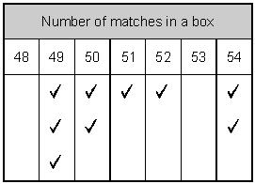

Calculate how many matches are in the 10th box.

Q3. Sarah makes a pie chart to show the proportion of boys and girls in her class.

 | Number in class | Size of angle on pie chart
Boys | 14 | 144⁰
Girls | 21 | 216⁰

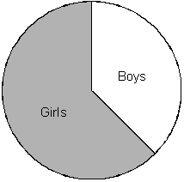

The next day another boy joins Sarah's class. She makes a new pie chart.
Calculate the angle for boys on the new pie chart.

Q4. This chart gives the cost of showing advertisements on television at different times.
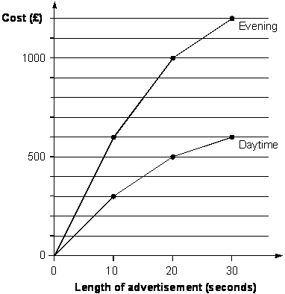
(a) An advertisement lasts 25 seconds. Use the graph to estimate how much cheaper it is to show it in the daytime compared with the evening.
(b) An advertisement was shown in the daytime and again in the evening. The total cost was £1200. How long was the advertisement in seconds?

Answers
1. (a) 36% (b) 46%
2. 52
3. 150⁰
4. (a) Between £540 and £560. (b) 15 seconds

Do you need more information?
Refer to Mathematics Explained for primary teachers by Derek Haylock, Section E, pages 339 to 378.

