Ratio and proportion activity 1
Once Upon a Time

Once upon a time there were three bears. There was Father Bear, Mother Bear and Baby Bear. But you knew that!

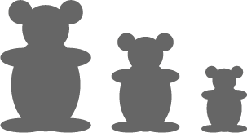

Mother Bear was three quarters the size of Father Bear.
Baby Bear was half the size of Father Bear.
And all the things they had were in the same proportions.
This means that Father Bear's chair was twice as big as Baby Bear's chair and Mother Bear's chair came exactly in between.

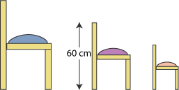

Mother Bear's chair was 60 cm high. How high were the other two chairs?

The diameter across the top of each Bear's porridge bowl was three times the height.

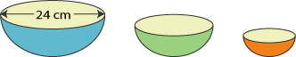

Father Bear's bowl was 24 cm across. What was the diameter of Mother Bear's bowl and the height of Baby Bear's bowl?

A little girl came to visit the three Bears. (Her name was Goldilocks - but you knew that too!)
Goldilocks had all the same things as the bears, but hers were all sorts of odd sizes, some nearly as big as Father Bear's, and some almost as small as Baby Bear's!

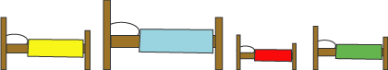

Who did all these beds belong to? You might need to do some measuring!

Father Bear's spoon was 30 cm long. Goldilocks' spoon was five sixths of that.

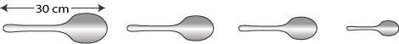

What proportion of Goldilocks' spoon was Baby Bear's spoon?

This activity taken from http://nrich.maths.org/

Teachers’ Notes
Why do this problem?
This problem is based on the story of the three bears, which is a good context in which to talk about ratio and proportion. In this case, it leads on to calculating with fractions.
Learners will need to be familiar with finding simple fractions of quantities before tackling this problem.

Possible approach
You could start by telling, or re-telling, the story of the three bears. Many children miss out on traditional English stories and the background is helpful here.

After this you could introduce the problem itself so that the group can discuss it. One of the difficulties of this topic is using the language appropriately, and the more you can encourage the class to talk about the relative sizes of the bears' and Goldilocks's things, the better.

Next learners could work in pairs so that they are able to talk through their ideas with a partner. They will be able to check that their solutions seem reasonable, given the information at the start of the problem and should be encouraged to do so.

The discussion at the end should consider the ideas about fractions and proportion introduced in the problem as well as the different answers to the questions posed. This is a good opportunity to check that the group is using the language appropriately and with understanding.

Key questions
If Mother Bear's chair is three quarters of the height of Father Bear's, what is one quarter of the height of Father Bear's chair?
So can you work out how tall Father Bear's chair is?
How can you work out the diameter of Baby Bear's bowl from the diameter of Father Bear's?
Why don't you try measuring the height of the beds?
What does it tell you about the sizes of the three bears at the beginning of the problem?

Solutions

Daddy Bear’s chair is 80 cm high, and Baby Bear’s chair is 40 cm high.

The diameter of Mother Bear’s bowl is 18cm. The diameter of Baby Bear’s bowl is 12 cm, so the height of the bowl is 4 cm.

The blue bed (second one along) is the biggest, so it must be Father Bear’s bed. The red bed (third one) is the smallest, so this must be baby bear’s bed. By measuring, you can find that the yellow bed (first one) is exactly between these two, so it must be Mother Bear’s bed. Therefore the green bed (fourth one) must be Goldilocks’.

Goldilocks’ spoon is 25 cm long and Baby Bear’s spoon is 15 cm long, so Baby Bear’s spoon is $\frac{3}{5}$ of Goldilocks’ spoon.

